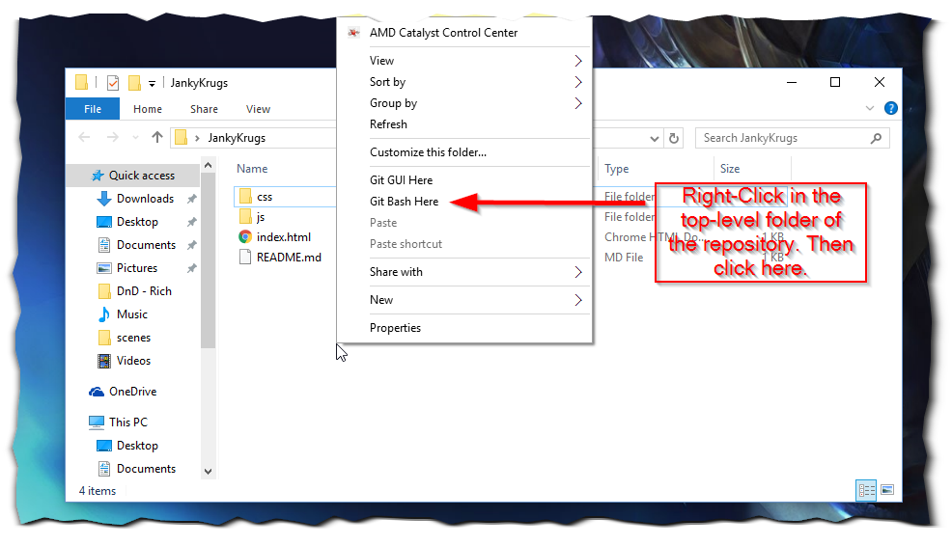

List of commands you might need:

Cloning – git clone https://github.com/newtjj/JankyKrugs.git

Sometimes you need to do this if added files that did not exist on github – git add --all

Commit comment – git commit -am “This is your commit.”

Push commit – git push

Pull new content – git pull